Project Design Phase-I Problem Solution Fit

|  |  |
| --- | --- |
| Date | 01 October 2022 |
| Team ID | PNT2022TMID27037 |
| Project Name | Smart Waste Management In Metropolitan Cities Using IoT |

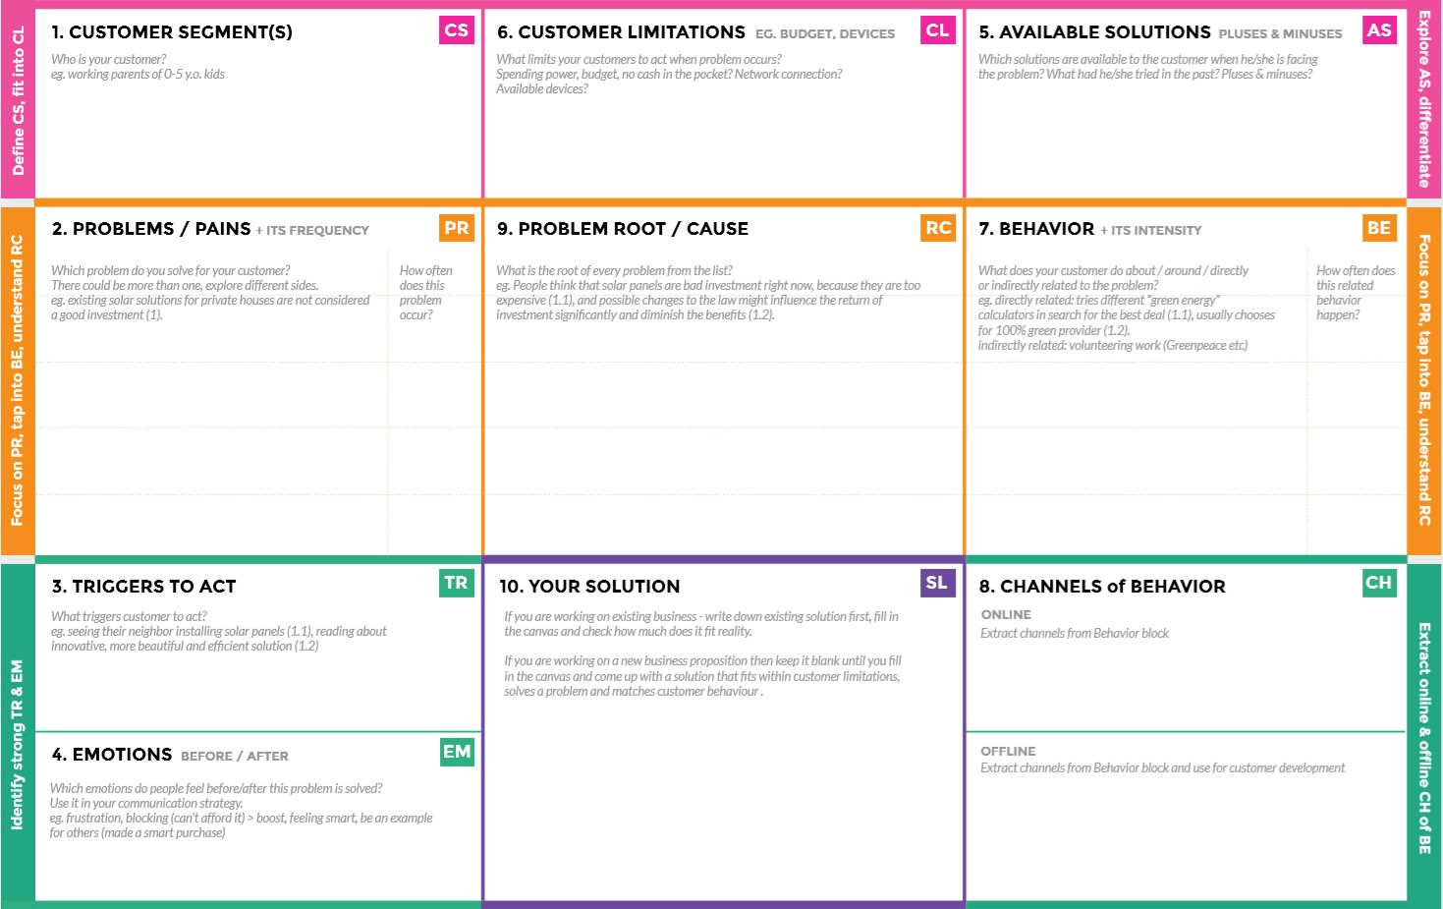

The manpower is reduced making

away from direct contact with the

waste as it is machine processed.

The monitoring and controlling of the leakage could be done by the sensors. Hence the manpower is reduced. Thus the environmental pollution is decreased and as well as the workers health is also increased.

High budget in installing other products make them to move far from modern technologies.

**Before:** The heavy leakage due to the overflow made us feel of guilt due to the workers were in direct contact with the waste.

**After:** Increased the level of confidence and feel secured and healthy.

Through newspaper advertisements.

Promoting through social media. With the help of social media entrepreneurs/influencer.

Develop an efficient system & an application that can monitor and alert the workers.

The heavy damages or higher health issues due to the direct contact of waste by human urges them to find out a solution as soon as they could possible.

When the sensors failed to monitor properly, the waste can overflow from the garbage dumpster.

* Decrease in air quality due to the unawareness of proper waste management.
* Having no proper system for controlling or monitoring the waste overflow from garbage dumpsters.
* Facing budget problems for installing the modern technology for waste management

The industrialists who promote recycling waste from the large dump yards